Pharmacological Sciences Training Grant Support Application 2022  Return completed Application Form to: rciochina@health.ucsd.edu by July 30, 2022 | 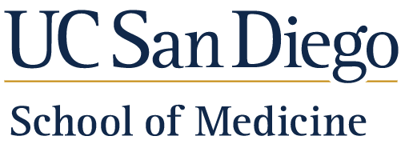  Department of Pharmacology

Personal Profile
Name
Email
Graduate Program
Year of Admission
Thesis Lab
Undergraduate University/College
Undergraduate G.P.A.
GRE if available | Scores: | Percentile:
 | Verbal
 | Quantitative
 | Analytical

Include your research experience prior to graduate school:

Lab Rotations
List your lab rotations with dates, since entering your graduate program:

P.I. | Dates
Lab selection: | Is the selection final? Yes No

Coursework Completed

Include information on coursework that you have completed.
PHAR255A: Molecular Basis of Drug Action & Disease Therapy I |  | Yes No
PHAR255B: Molecular Basis of Drug Action & Disease Therapy II  PHAR 222: Fundamentals of Cancer Biology  SPPS 263: Principles of Pharmaceutical Science & Drug Development |  | Yes No  Yes No  Yes No
List other courses you have taken, including any from the Pharmacological Sciences Training Grant Curriculum (see attached):

Research Project
Provide a brief synopsis of your planned research project, including how it relates to pharmacology. Also provide a list of any publications or abstracts from your current or past work.
Research Project
Publications

Awards and/or Honors
List any awards or honors that you have received (e.g., fellowships, poster awards, etc…)

Career Goals
Provide a brief summary of your career goals.

Diversity

Provide a brief summary of your experience with or contributions to diversity.

Agreement and Signature

By submitting this application, I affirm that the facts set forth in it are true and complete.
eSignature
Date

