Cell and Molecular Pharmacology Training Grant Support Application 2025  Return completed Application Form to: rciochina@health.ucsd.edu by August 1st, 2025 | 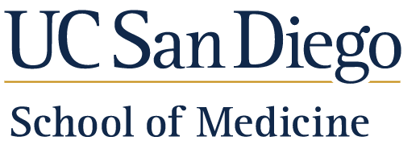  Department of Pharmacology

Personal Profile
Name
Email
Graduate Program
Year of Admission
Thesis Lab
Undergraduate University/College
Undergraduate G.P.A.
GRE if available | Scores: | Percentile:
 | Verbal
 | Quantitative
 | Analytical

Describe your research experience prior to graduate school : In half a page or less, indicate where you conducted the research, for how long, the goals of your project and any major findings or accomplishments

Lab Rotations
List the faculty with whom you conducted lab rotations and the dates of the rotations:

P.I. Name (first, last) | Dates (approximate start date and end date)
Lab selection: | Is the selection final? Yes No

Coursework Completed

Indicate the coursework that you have completed.
PHAR275: Seminars in Pharmacology |  | Yes No
PHAR255: Molecular Basis of Drug Action & Disease Therapy |  | Yes No
PHAR 222: Fundamentals of Cancer Biology  SPPS 263: Principles of Pharmaceutical Science & Drug Development |  | Yes No  Yes No
List other courses you have taken, including any from the Pharmacological Sciences Training Grant Curriculum (see attached).

Research Project
Provide a brief (1/2 page or less) synopsis of your planned research project. Include how it relates to pharmacology. Also provide a list of any publications or abstracts from your current or past work (this may be in addition to the ½ page synopsis).
Research Project
Publications

Awards and/or Honors
List awards and honors that you have received (e.g., fellowships, poster awards, etc)

Career Goals
Provide a brief summary of your career goals (no more than ¼ page).

Agreement and Signature

By submitting this application, I affirm that the facts set forth in it are true and complete.
eSignature
Date

